Steam

Project 1: What is your favorite IR (search) system?

By

Mr. WARIS DAMKHAM 6388014

**Submitted to  
Assoc. Prof. Dr. Suppawong Tuarob**

A Report Submitted in Partial Fulfillment of

the Requirements for

ITCS 414 – Information Retrieval and Storage

Faculty of Information and Communication Technology

Mahidol University

2021

**Table of Contents**

**Steam** 1

**Target Customer** 1

**Gender** 1

**Age** 2

**Location** 2

**Information that users need** 3

**Game’s name** 3

**Keyword** 4

**Publisher** 5

**Game tag** 5

**How can the search system help satisfy these information needs?** 6

**Relevance** 6

**Release date** 6

**Name** 6

**Steam deck compatibility review date** 6

**User reviews** 7

**Lowest price** 7

**Highest price** 7

**Example scenario in information needs** 8

**Reference** 12

# **Steam**

Valve's Steam is an online platform for purchasing, playing, creating, and discussing PC games. The cloud-based gaming library Steam. The platform offers thousands of games (along with downloadable content, or DLC, and user-generated features known as "mods") from large studios and independent game developers.

Steam has various content of the game for any type of user because Steam also separates the category of the game, it has content about description, price, short video, Publisher, and system requirements for that game.

This search engine may be used through steampowered.com or by downloading Steam and using the search bar to locate any game. Users may search for the game's name or a keyword, after which the system will display the game's description and pricing. In addition, Steam's algorithm can rank the best-selling game. Additionally, the system features a filter search for the lowest price, highest price, and release date to accommodate the gaming interests of nearly everyone.

# **Target Customer**

Steam is the greatest destination for gamers to play, discuss, and create games. Therefore, the target customer of Steam is the people who are interested in playing games and want to relax by playing games, but Steam not only sale about game but have some software, soundtrack, and Videos that related game. But Steam customer must be at least 13 years old to use Steam, though not all games are suitable for young teens. The data in December 2021 can be divided into the following:

## **Gender**

As of December 2021, most of the gamers on Steam are male at 88.1% compared to 2.4% female and 9.5% unknown.

## **Age**

2021 data reports that the average age of Steam users is between 20 and 9 years old, which accounts for about 37% adult users.

* 18-19: 8%
* 20-29: 37%
* 30-39: 32%
* 40-49: 15%
* 50-59: 7%
* 60-64: 1%

## **Location**

The United States makes up most of the users on Steam, with China coming in second. Let’s look at how Steam user’s breakdown by location.

* United States: 14.43%
* China: 11.64%
* Russia: 9.57%
* Brazil: 4.77%
* Germany: 4.16%
* Canada: 3.11%
* France: 3.04%
* United Kingdom: 3%
* Poland: 2.6%
* Turkey: 2.38%

# **Information that users need**

Steam is comprised of several contents, each of which has its own information needs. When we wish to download certain games, the name of the game is the first thing that comes to mind. Then, we check up the game's title.

Game’s name:** It displays a list of games that match your search criteria. Users may choose their desired game by clicking on it. The game's price, description, system requirements, and release date will then be shown.

List of filters that user can use:  
- Price  
- Game tag

- Type of products

- Number of players

- Feature

- Deck Compatibility

- VR Support

- Operating System

- Language

Additionally, Steam can filter the information according to your choices, such as by name, release date, user rating, lowest price, and highest price.

**Keyword:** It will offer a list of games that match your search requirements. If the user does not know the complete name of the game, they can input a keyword to see games that are relevant to that term.

Try looking for games that use game types with names such as MOBA. On pages that may be filtered according to our requirements, you will discover games with this gameplay style.

**Publisher:** When we play a game that we truly enjoy and desire more like it, we may sometimes obtain it from the publisher or creator.

We really like the game "Elden Ring" and want to play more games like this, so we searched for the developer and publisher names. We will find games from developers and publishers.

**Game tag:** When we play a game that we really appreciate and want to find more like it, we may occasionally find it through its tag or category.

We want to play other games similar to "Elden Ring," thus we looked for the game tag or game category. We will locate games with the specified game tag or game category.

# **How can the search system help satisfy these information needs?**

How can the search system help satisfy these informational requirements? The search method on Steam also uses the game's name, a keyword, and the game's publisher to retrieve the desired information. When users make a search using the name of a game, for instance, the most relevant results will be presented by default. In addition, Steam may filter the information according on your preferences, including release date, name, Steam deck compatibility review date, user ratings, lowest price, and highest price.

**List of results select content and display based on:**

## **Relevance**

Relevancy was the default setting of the search system. The game most relevant to your search will display first in the list.

## **Release date**

The most current release date shows at the top of the list when users select the release date as a filter.

## **Name**

Sort alphabetically by letter A-Z based on your search.

## **Steam deck compatibility review date**

The Steam Deck is a portable gaming device of the next generation that allows gamers to take their Steam library with them on the couch or on the go. The Steam Deck has a high-resolution display, full-size ergonomic controllers, an enhanced Steam user interface, and sufficient processing power to run current-generation games.

## **User reviews**

**Digging Deeper**

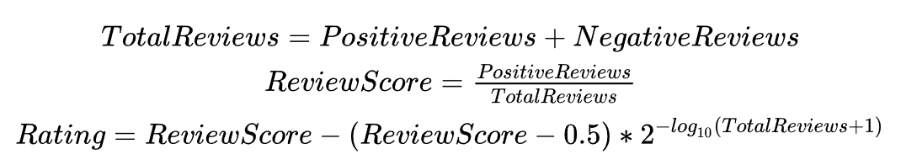By examining the search results, I have a decent understanding of how Steam generates the semantic groupings.

* 95 - 99%: Overwhelmingly Positive
* 94 - 80%: Very Positive
* 80 - 99% + few reviews: Positive
* 70 - 79%: Mostly Positive
* 40 - 69%: Mixed
* 20? - 39%: Mostly Negative
* 0 - 39% + raw reviews: Negative
* 0 - 19%: Very Negative
* 0 - 19% + many reviews: Overwhelmingly Negative

## **Lowest price**

Sorting from lowest to highest price.

## **Highest price**

Sorting from highest to lowest price.

# **Example scenario in information needs**

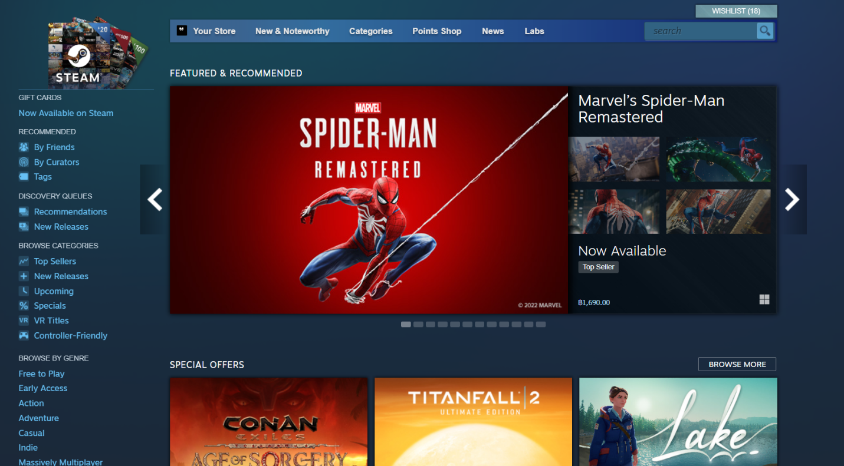When customers browse Steam via store.steampowered.com or download the Steam application, the first page of Steam is shown. This page includes a variety of content. This page's search box will appear in the upper-right hand corner.

First pages of Steam application

For example, users search for the game’s name "dark soul" in the search box.

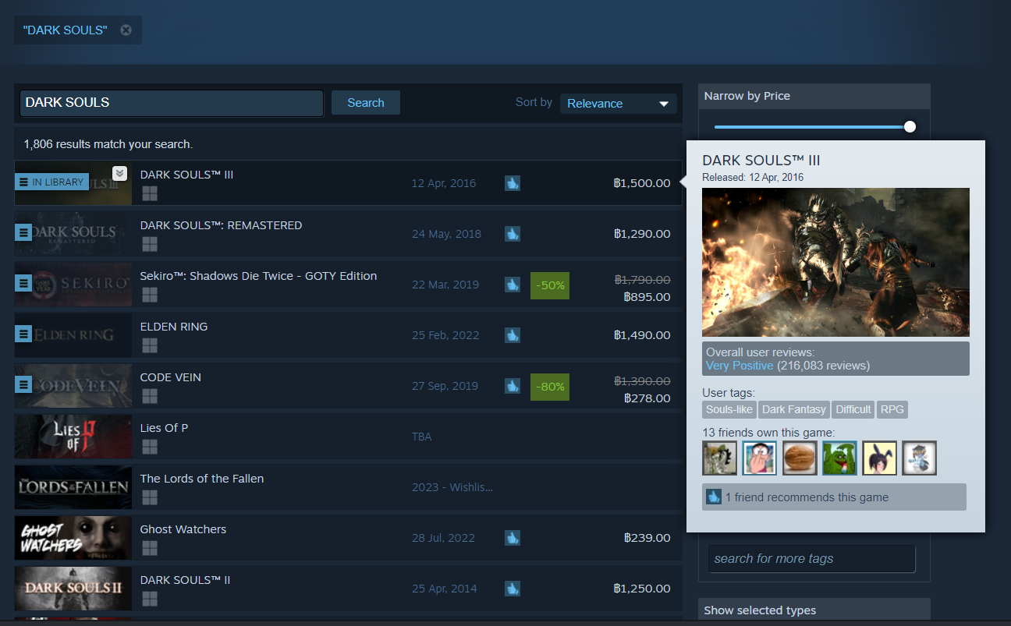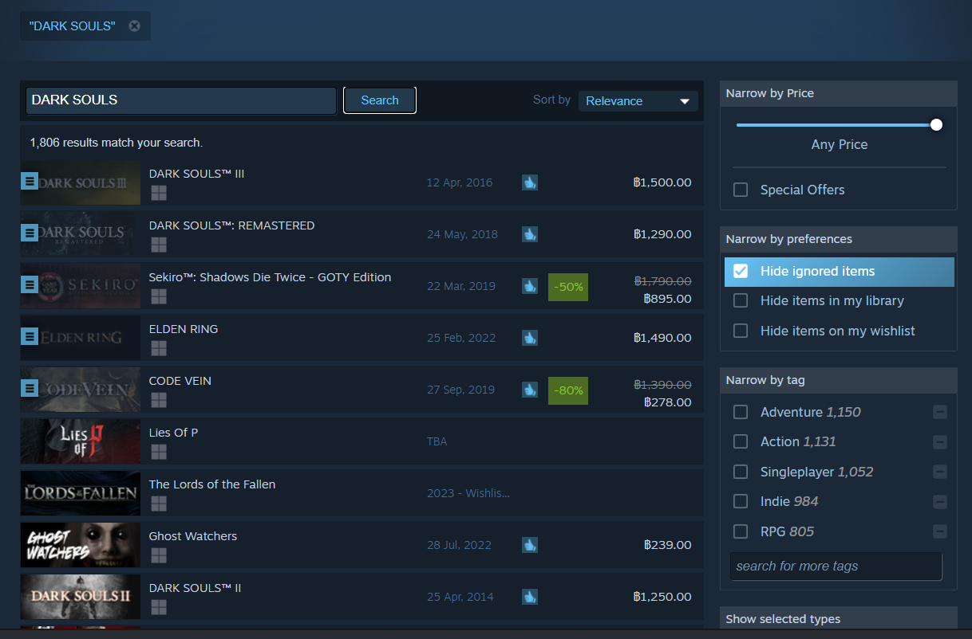

If you hold the mouse on the search results, it will show a popup about the short information.

After the click of the search button, the relevant search results will be shown. This page will be organized according to relevancy.

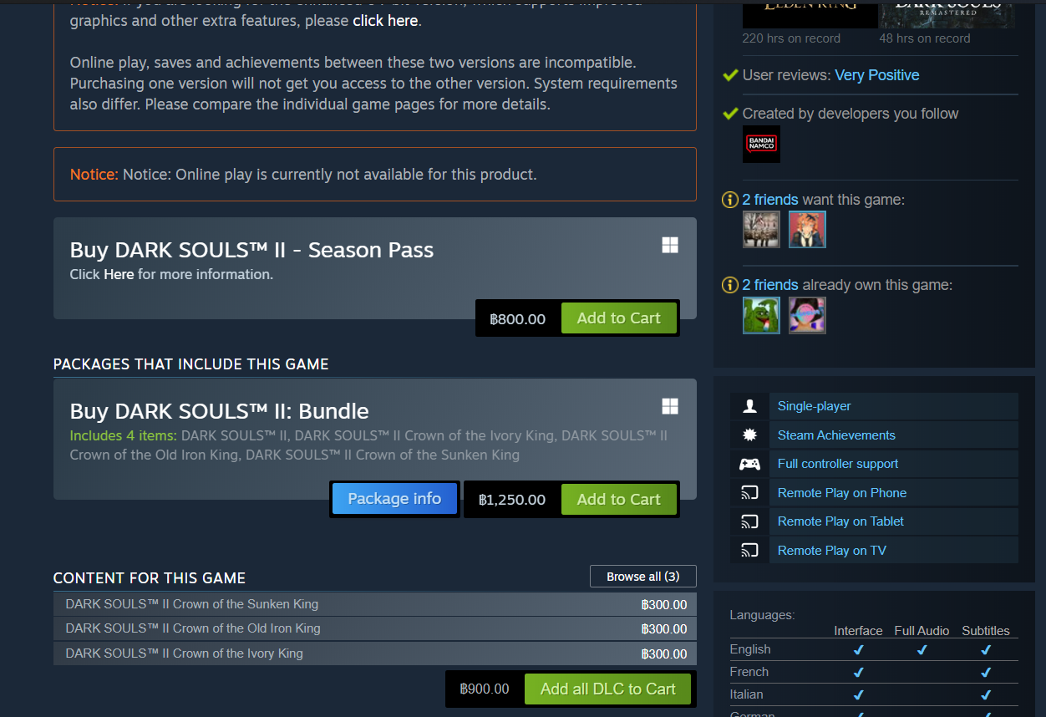

If you haven't purchased this game, it will show the price and have a button "Add to Cart" to continue to the payment section.

Show information about that game and System requirements.

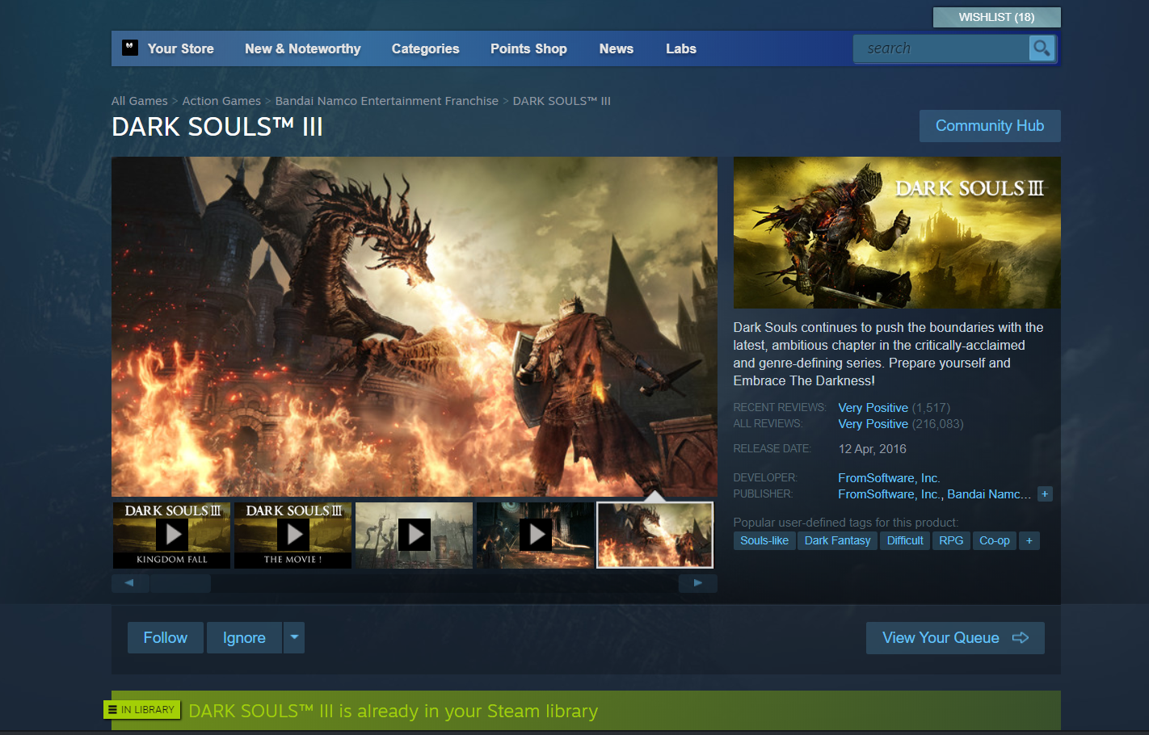

The last page will show the game from the publisher or creator and more like this game.

DARK SOULS III is already in your Steam library if you have already purchased it.

# **Reference**

Store.steampowered.com. 2022. Steam Store. [online] Available at: <https://store.steampowered.com> [Accessed 2 September 2022].

Game World Observer. 2022. Steam’s algorithms demythologized | Game World Observer. [online] Available at: <https://gameworldobserver.com/2020/09/23/steam-algorithm> [Accessed 2 September 2022].

Medium. 2022. Who is Playing Games on Steam? [online] Available at: [https://cbrownell.medium.com/who-is-playing-games-on-steam-e765142cd983](https://cbrownell.medium.com/who-is-playing-games-on-steam-e765142cd983%20) [Accessed 2 September 2022].

Common Sense Media. 2022. Parents' Ultimate Guide to Steam. [online] Available at: [https://www.commonsensemedia.org/articles/parents-ultimate-guide-to-steam](https://www.commonsensemedia.org/articles/parents-ultimate-guide-to-steam%20%20%20%20%20%20%20%20%20%20%20%20%20%20%20%20%20%20%20%20%20%20%20%20%20%20%20%20%20%20)  [Accessed 2 September 2022].

Doucet, Lars. “Fixing Steam’s User Rating Charts.” *Game Developer*, 6 Oct. 2014, <www.gamedeveloper.com/business/fixing-steam-s-user-rating-charts>.

“SteamDB.” *Steam Database*, [steamdb.info/blog/steamdb-rating](https://steamdb.info/blog/steamdb-rating/). Accessed 2 Sept. 2022.